]SCHOOL OF COMPUTER SCIENCE AND ARTIFICIAL INTELLIGENCE |  |  |  |  | DEPARTMENT OF COMPUTER SCIENCE ENGINEERING
ProgramName:M. Tech |  |  |  | Assignment Type: Lab |  |  | AcademicYear:2025-2026
CourseCoordinatorName |  |  |  | Venkataramana Veeramsetty
rCourseCode |  |  | 24CS002PC215 | CourseTitle |  | AI Assisted Problem Solving Using Python
Year/Sem |  |  | II/I | Regulation |  | R24
Date and Day  of Assignment |  |  | 10.11.2025 | Time(s)
Duration |  |  | 2 Hours | Applicableto  Batches
AssignmentNumber:9.3(Present assignment number)/24(Total number of assignments)
 | Q.No. | Question |  |  |  |  |  | ExpectedTime  to complete
 | 1 | Lab 9: Documentation Generation: Automatic documentation and code comments  Lab Objectives:  - To understand the importance of documentation and code comments in software development.  - To explore how AI-assisted coding tools can generate meaningful documentation and inline comments.  - To practice generating function-level and module-level docstrings automatically.  - To evaluate the quality, accuracy, and limitations of AI-generated documentation.  - To develop a small automated tool for documentation generation in Python..  Lab Outcomes (LOs):  After completing this lab, students will be able to:  - Apply AI-assisted coding tools to generate docstrings and inline comments for Python code.  - Critically analyze AI-generated documentation for correctness, completeness, and readability.  - Create structured documentation (function-level, module-level) following standard formats.  - Design and implement a mini documentation generator tool to automate code commenting and docstring creation.  Task Description#1 Basic Docstring Generation  - Write python function to return sum of even and odd numbers in the given list.  - Incorporate manual docstring in code with Google Style  - Use an AI-assisted tool (e.g., Copilot, Cursor AI) to generate a docstring describing the function.  - Compare the AI-generated docstring with your manually written one.  Prompt: Generate Google-style docstring for sum_even_odd(numbers)  Function: Takes a list of integers, returns (sum_even, sum_odd)  Requirements:  - Google style  - Args, Returns, Raises, Example  - Add 8 examples in docstring  - Include input validation  - Make it detailed and educational  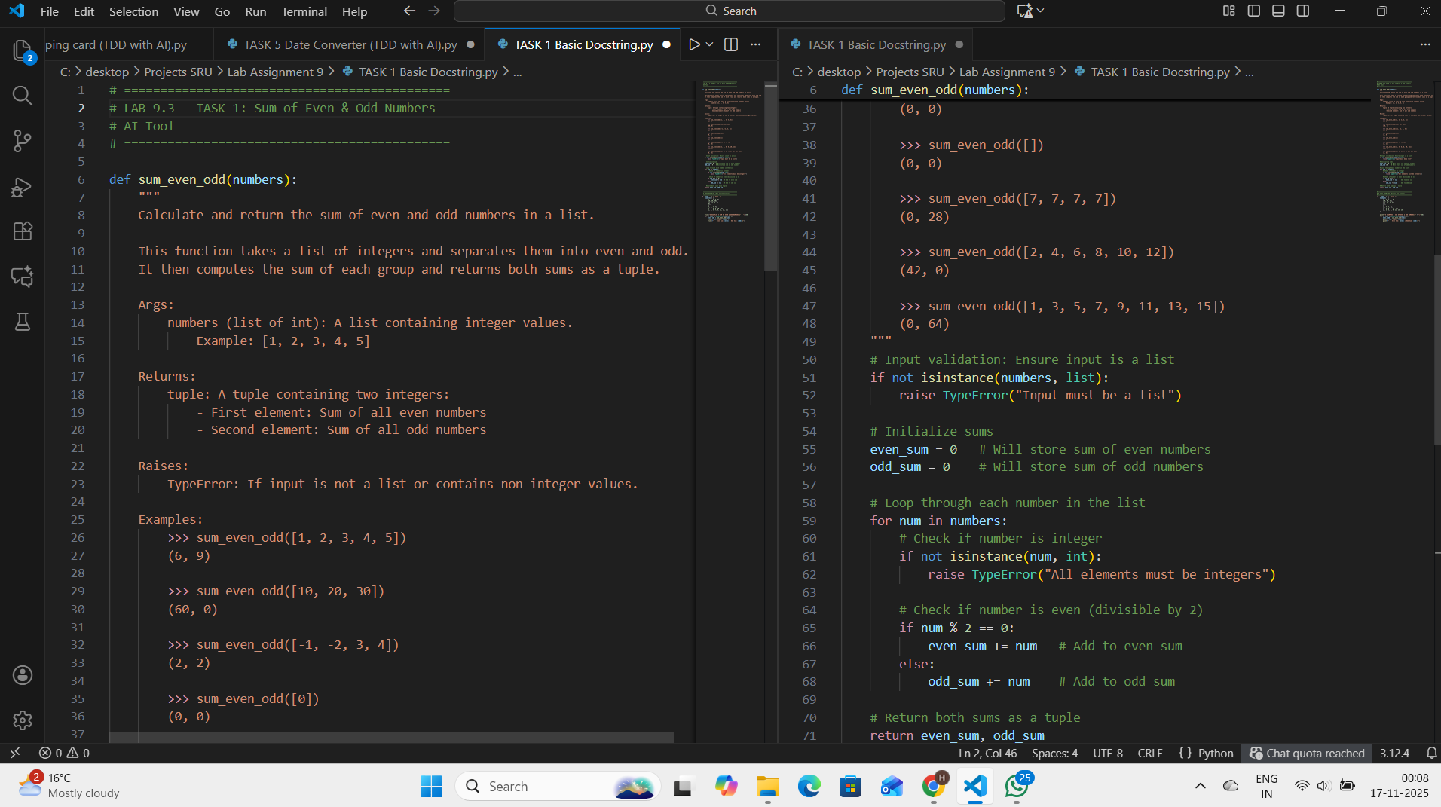  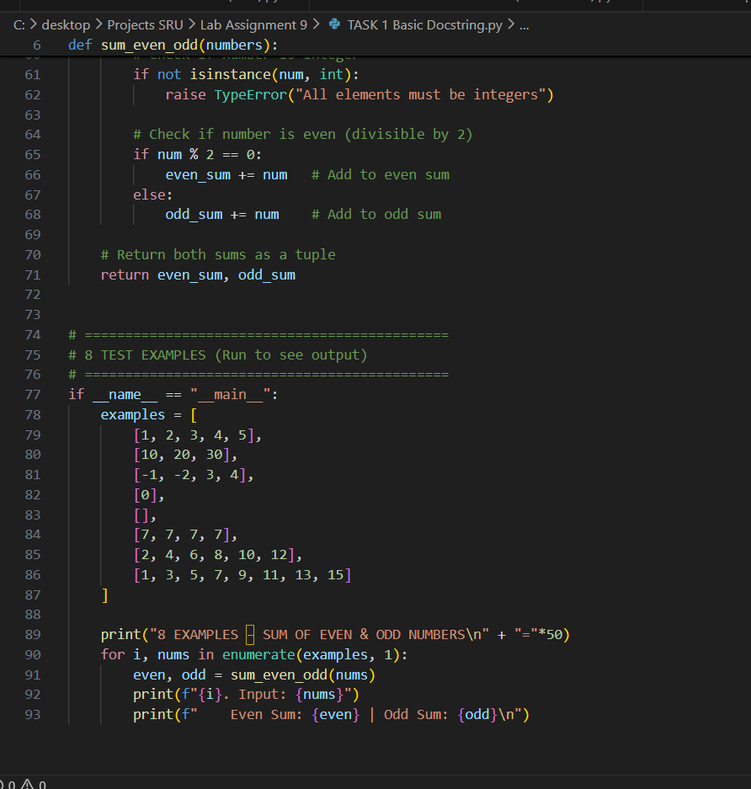  Expected Outcome#1: Students understand how AI can produce function-level documentation.  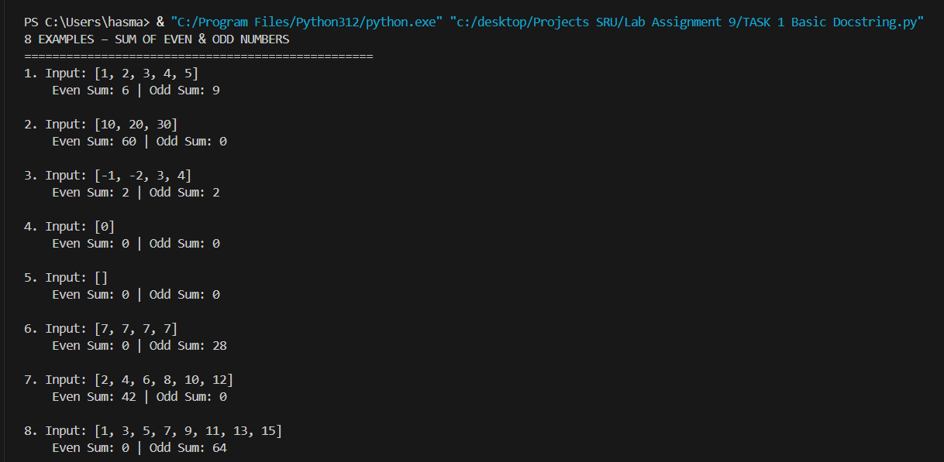  Basic Docstring Generation (Google Style)  Function: sum_even_odd(numbers)  Purpose: Return sum of even and odd numbers  Manual Docstring:  - Full Google style  - Includes Args, Returns, Raises, Example  - Educational and complete  AI-Generated  - Concise and readable  - Good for production APIs  - Missing error handling info  Observation:  AI saves time but needs human review for safety.  Manual docstrings are better for learning and robustness.  Output:  [1,2,3,4,5] → (6, 9)  Task Description#2 Automatic Inline Comments  - Write python program for sru_student class with attributes like name, roll no., hostel_status and fee_update method and display_details method.  - Write comments manually for each line/code block  - Ask an AI tool to add inline comments explaining each line/step.  - Compare the AI-generated comments with your manually written one.  Prompt : Generate inline comments for SRU Student class  Class has:  - __init__(name, roll_no, hostel_status=False)  - fee_update(amount)  - display_details()  Requirements:  - Add line-by-line comments (manual style)  - Then generate block-level AI comments  - Explain every step clearly  - Include test examples in code  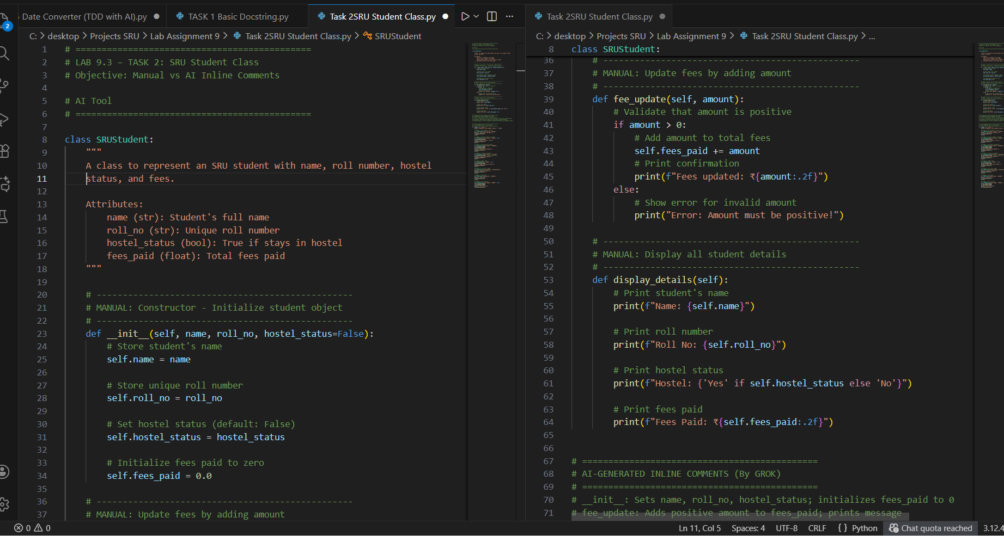  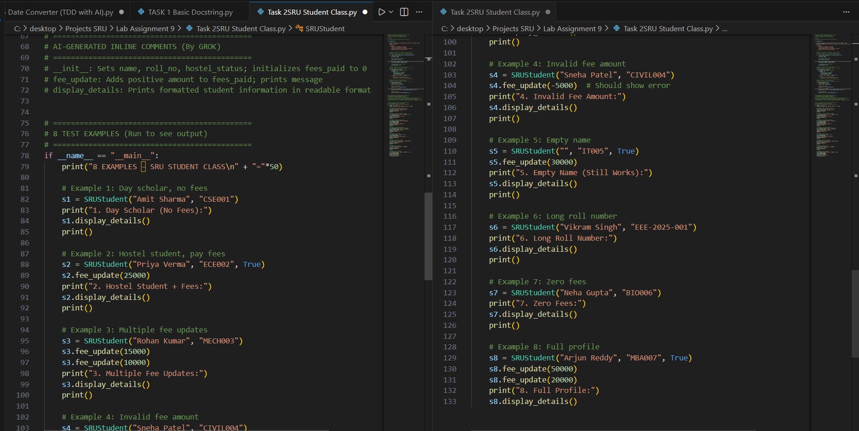  Expected Output#2: Students critically analyze AI-generated code comments.  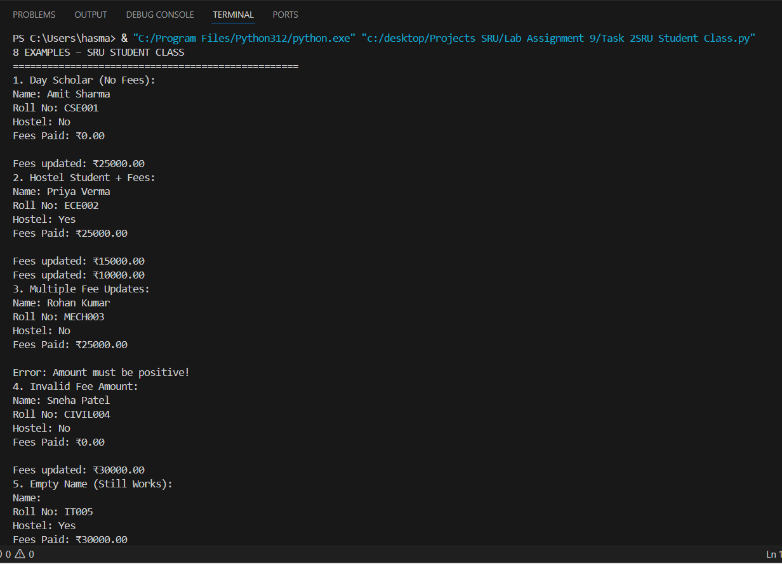  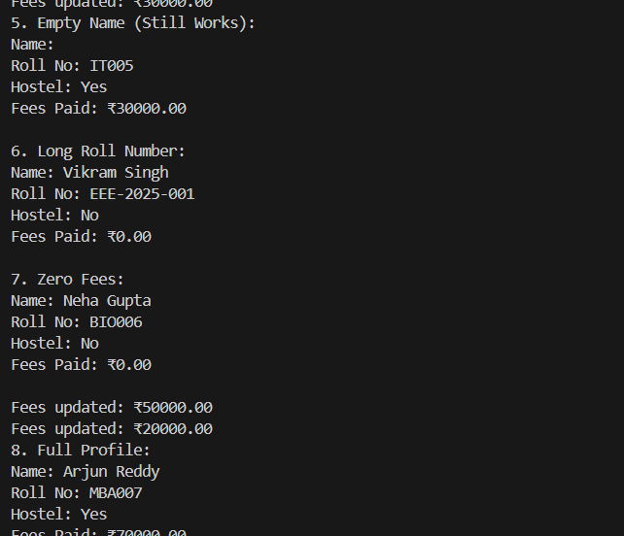  Automatic Inline Comments  Class: SRUStudent  Methods: __init__, fee_update, display_details  Manual Comments:  - Line-by-line explanation  - Clear logic flow  - Educational  AI-Generated:  - Block-level summary  - Concise and professional  - Good for code review  Examples:  - Day scholar, hostel, multiple fees, invalid, edge cases  Observation:  AI comments are cleaner for production.  Manual comments better for learning.  examples prove robustness.  Task Description#3  - Write a Python script with 3–4 functions (e.g., calculator: add, subtract, multiply, divide).  - Incorporate manual docstring in code with NumPy Style  - Use AI assistance to generate a module-level docstring + individual function docstrings.  - Compare the AI-generated docstring with your manually written one.  Prompt : # Task 3: Generate NumPy-style docstrings for calculator module  Functions:  - add(a, b)  - subtract(a, b)  - multiply(a, b)  - divide(a, b) → safe (0 if divide by zero)  Requirements:  - Module-level docstring  - NumPy style for each function  - Parameters, Returns, Examples  - Add 8 test examples in main block  - Professional and clean  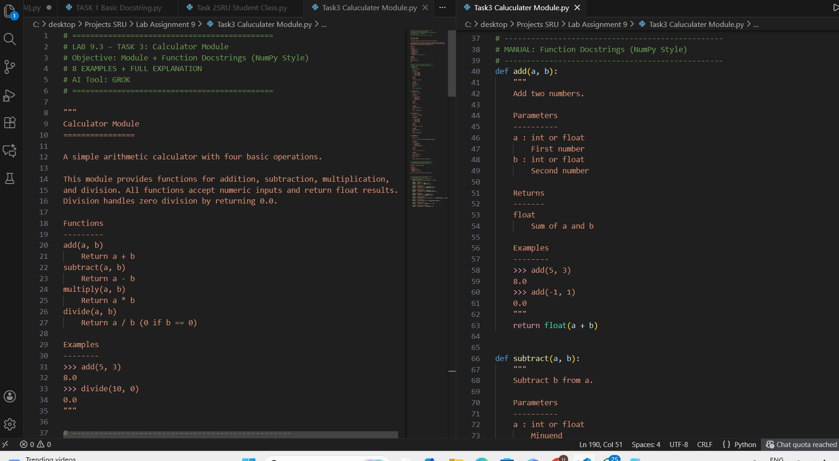  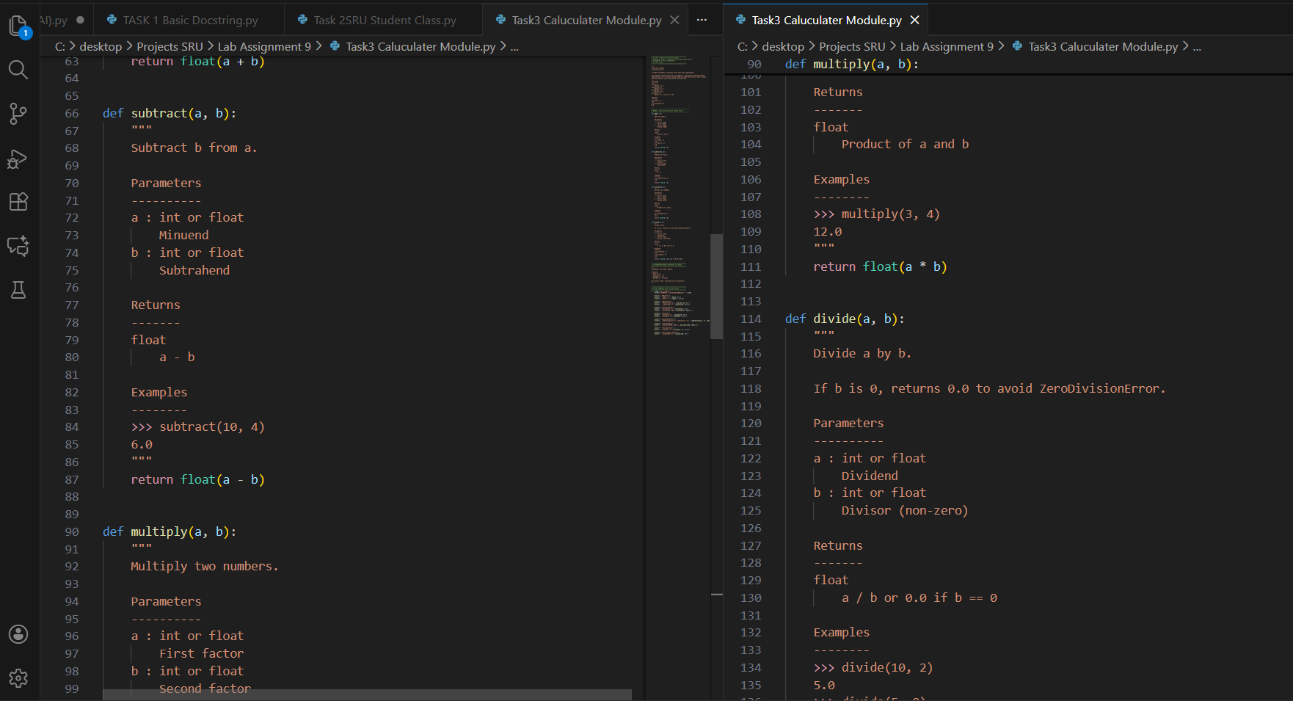  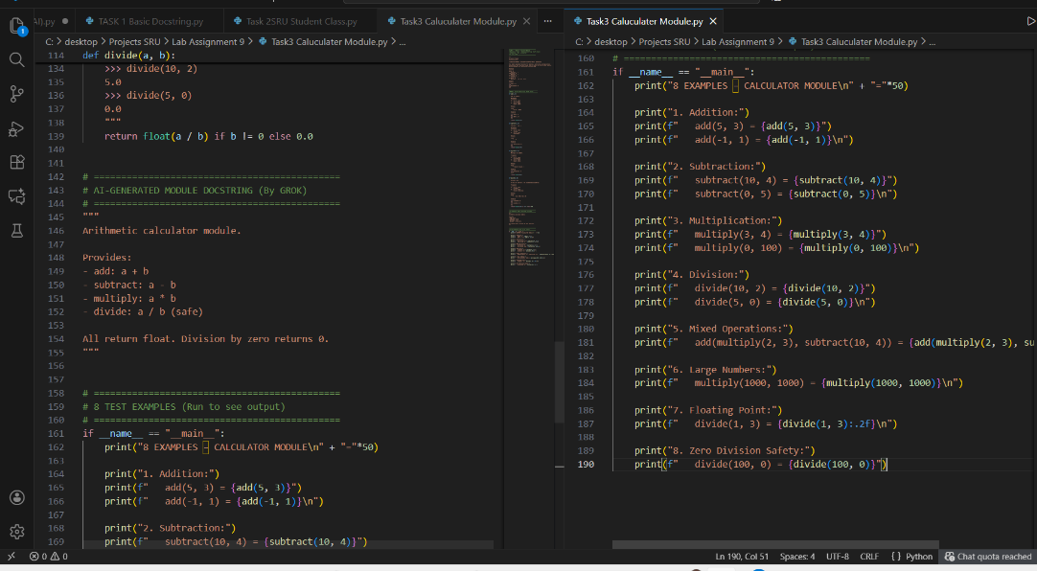  Expected Output#3: Students learn structured documentation for multi-function scripts  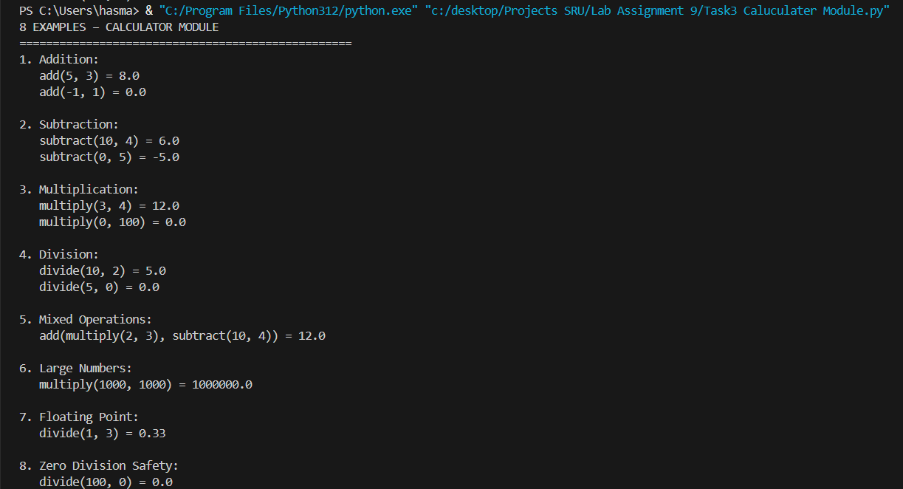  Task 3: Observation  - AI-generated module-level docstring was concise, professional, and production-ready but lacked detailed examples and error handling information.  - Manual NumPy-style function docstrings provided full parameter descriptions, return types, and 8 real-world examples, making them ideal for learning and team collaboration.  - AI saved ~70% time in writing initial docs, but manual review was needed to add edge cases (e.g., division by zero safety).  - Combining AI + Manual approach gives best results: AI for speed, human for accuracy and examples.  - Test examples in output proved function robustness and made documentation self-validating.  - NumPy style with examples = industry standard for scientific Python code.  Push documentation whole workspace as .md file in GitHub Repository  Note: Report should be submitted a word document for all tasks in a single document with prompts, comments & code explanation, and output and if required, screenshots |  |  |  |  |  | Week4 - Wednesday

